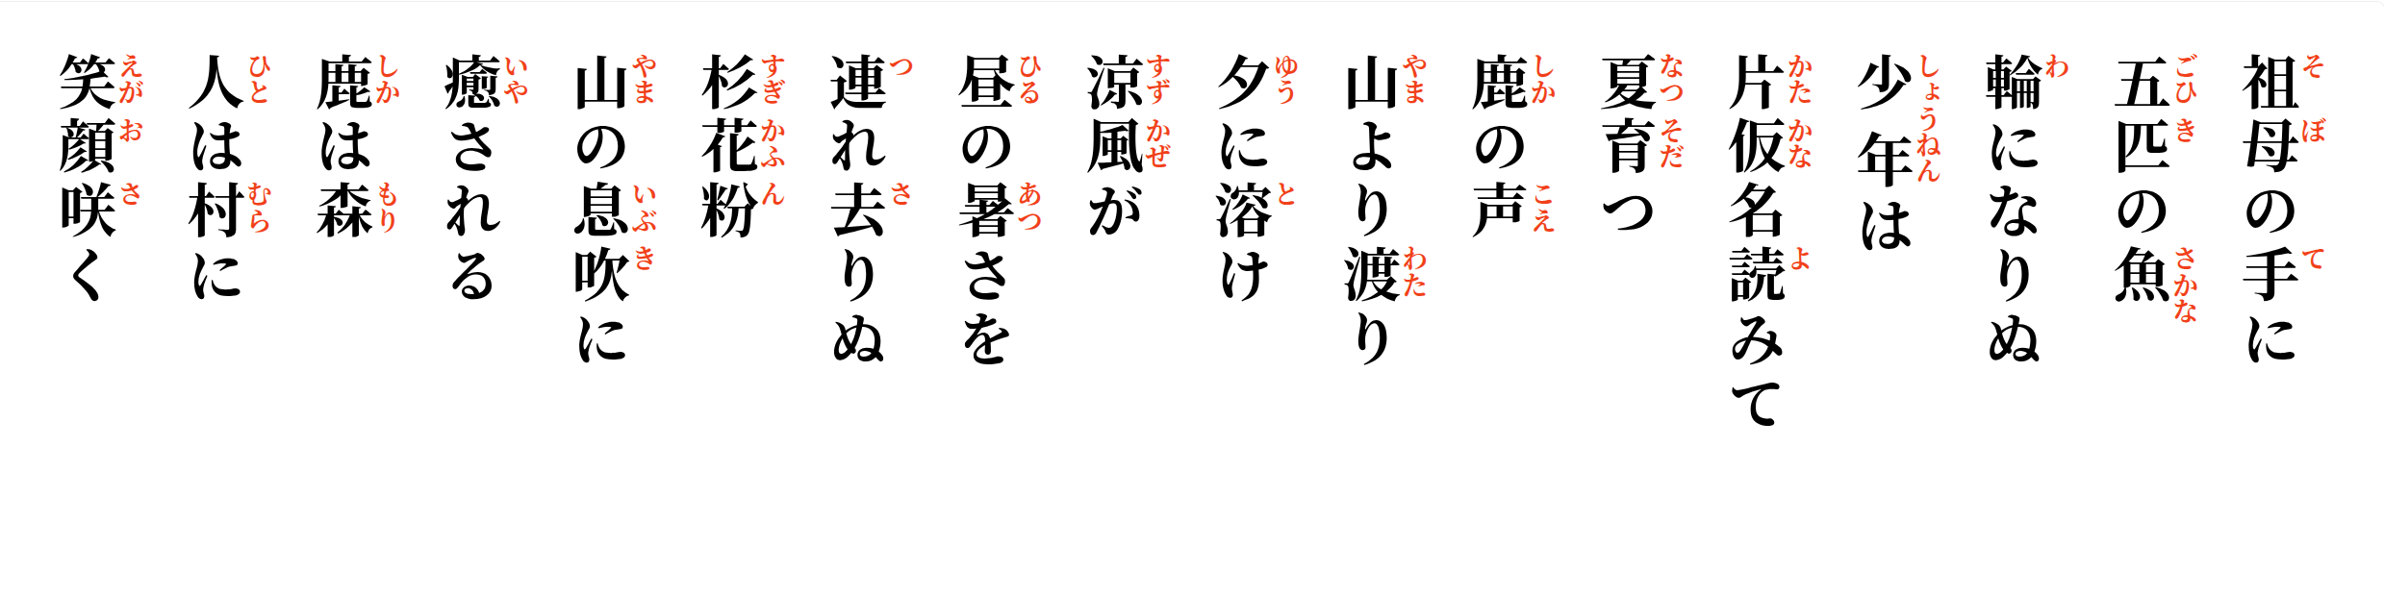
Deer remain
deep in the forest,
while smiles bloom in the village.


Cedar pollen—
eased by the mountain's breath,
healing returns.
The cry of a deer
drifts across the mountain
into evening.
The cry of a deer
drifts across the mountain
into evening.
A young boy
sounding out katakana;
summer grows.

